Aircraft Manufacturing and Assembly

Name
Instructor
Institution

Date

The fuselage can be defined as the main body that is found in the fixed-wing aircraft. The main purpose of the fuselage is to offer space for passengers, accessories, controls, and cargo. The fuselage acts as the power plant for any single-engine aircraft. The multiengine aircraft has an engine that can be either suspended from the wing or fuselage. There are two main types of the fuselage that include monocoque and truss. The monocoque is a type of fuselage that depends mainly on the strength of the covering or skin to carry the main loads. Its design includes semimonocoque and monocoque. The portions may include both classes of the fuselage, however, the majority of the aircraft are known to use semimonocoque. The main monocoque applies bulkheads, assemblies, frame, and formers to present good shape to the fuselage. Construction of the monocoque has problems that include the high cost of maintaining the required strength while maintaining the required strength that keeps the weight within the permissible limits.
The semimonocoque type was established to overcome the weight or strength problem in any monocoque construction. It has a frame assembly, formers, and bulkheads that are used for in the monocoque design. Additionally, they are used as skin reinforcement by longitudinal members known as longerons. The longerons extend in different frame members and assist the skin to support the main bending loads. The other type of the fuselage is known as the truss. It is a strong framework that has members like bars, strut, and beams to resist deformation by loads.
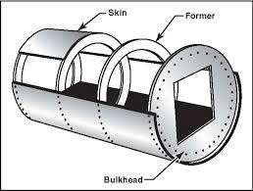

The truss-framed fuselage in covered by fabric. This type of fuselage is constructed by steel tubing that is welded together to ensure that all members found in truss can sustain compression and tension loads. In most aircraft, the single-light engine types, truss fuselage frames are developed using aluminum alloy and can be bolted into a single piece.
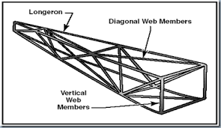
An example of the truss fuselage
Wing spars are the main structural parts of the wing. The spars match to the longerons of the fuselage. The spars are located parallel to the fuselage longerons. They correspond with the lateral axis of the aircraft running from the fuselage to the tip of the wing. They are normally fitted to the fuselage by the truss, plain beams or wing fittings. The wing spars may be made of composite material, wood or metal depending on the design or purpose of the aircraft. Normally, most aircraft have wing spars there are made from aluminum extrusions reverted jointly to make a spar. Using composites makes airmen be more vigilant for wings spars that are from different materials.
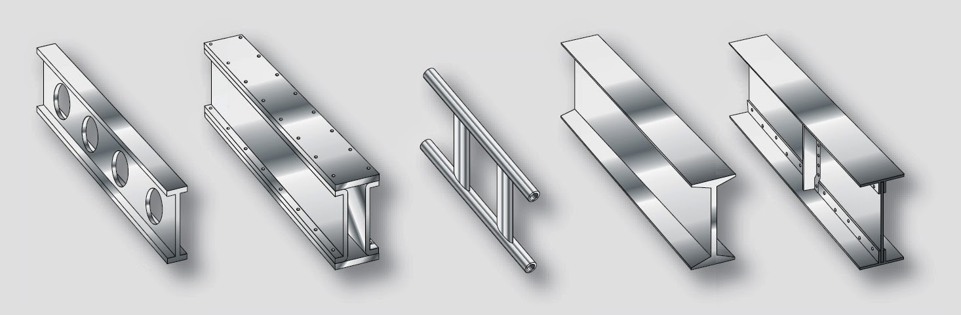
An example of metal wing spar shapes
The spar has an I-beam which has a top known as the caps and the section on the vertical side is known as the web. The whole spar can be extruded from a single part of the metal but it is normally made from different extrusions. The web is part of the depth that is found in the spar. All these members have loads occasioned by wing bending and the caps provides the foundation for fastening the skin.
There is a slight difference between the spar and the stringer or a longeron. A stringer or longeron is a tough strip of carbon fiber, wood strip or strip that enables the fastening of the aircraft skin. Longerons are ascribed to formers in the event of ribs or fuselage in case of empennage or a wing. Initially, the aircraft fabric cover was attached to the longerons and stretched tightly by dope painting that would ensure that that the fabric shrunk and achieved stiffness. The nacelle has a framework that is made structural members that look like the fuselage. The stringers and longerons have a length combining the bulkheads, formers, and rings that give the nacelle the required shape that fits the structures. The structure that forms a separation of the engine from the entire aircraft is known as the firewall. It is a titanium or stainless steel bulkhead which has a fire in the confines of the nacelle. The nacelle has engine mounts which are important to the operation of the material. They are constructed from the molybdenum steel tubing in forged chrome assemblies in bigger aircraft.
The outer side of the nacelle has a skin that can be opened to access the aircraft engine and different components on the outer side. All of them are normally manufactured using magnesium alloy or sheet aluminum with titanium alloys or stainless steel used in areas with high temperatures such as exhaust exit. Irrespective of the material applied, the skin is attached to the framework using rivets. Cowling is a terminology that means the detachable panels that cover parts that must ensure accessibility regularly. It includes the accessories of the engine. It developed to offer a smooth flow of air in the nacelle and also helps to protect the engine from the external damages. The panels found in the cowl are made from aluminum alloy. However, stainless steel is the most common material used in the inner skin aft in the section of the power. It is also important because it helps to facilitate oil cooler ducts. Cowl flaps are convenient because they can be moved from one place to another and can help in regulation of the engine temperature.

References
Aircraft structures a brief history of aircraft structures chapter 1

